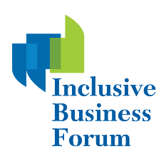
Accessibility Guide
Accessing Closed Captions
- Select “Closed Caption” at the bottom of your screen
- After selecting “Closed Caption”, select “Show Subtitle”, you will see the captioning at the bottom of your screen
- You can also access the live transcript by clicking on the link provided below. The link will also be made available to you in the Zoom chat box.
Click here to access the live transcript

Adjusting Your Caption Size
- Click on the arrow next to stop/start video and choose “Video Settings”
- Click on “Accessibility”
- Move the slider to adjust the caption size

Viewing the Singapore Sign Language (SgSL) Interpreter
- Click “View Options” and then select the “Side by Side” option at the top of your screen to view both the live Singapore Sign Language interpreter and the speakers
- You can also adjust the video sizes of both the Singapore Sign Language interpreter and the speakers by shifting the line divider

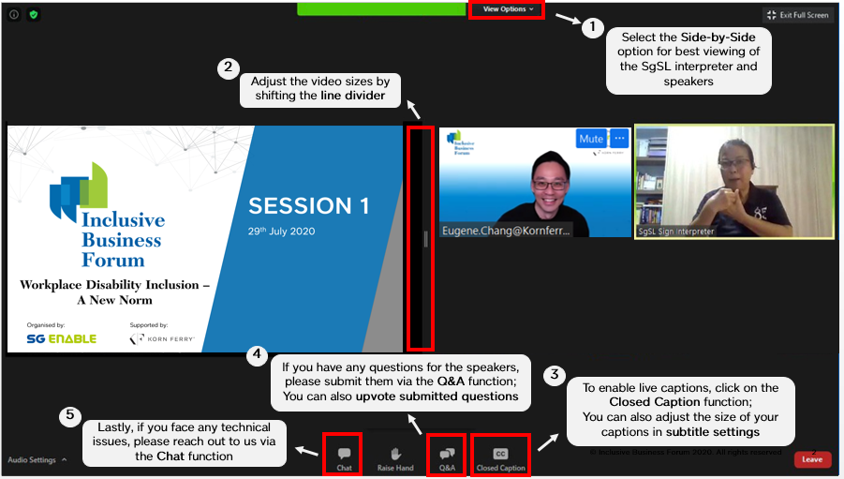

© Inclusive Business Forum 2020. All rights reserved.

